

|  |
| --- |
| Hemanth, Prathik, Akash, Akshya.Internet Of Things -Project |
|  |

|  |  |  |
| --- | --- | --- |
| Medicine Reminder For Elderly People Using IBM Cloud | |  |
| 01Introduction02Literature Survey03 **04**  05  06  07  08  09 Theoretical Analysis  1. Existing problem 2. Proposed solution   **Experimental Investigation**  **Flowchart**  **Result**  **Advantages & Disadvantages**  **Application**  **Conclusion** | INTRODUCTION  Sometimes elderly people forget to take the medicine at the correct time. They also forget which medicine He / She should take at that particular time... And it is difficult for doctors/caretakers to monitor the patients around the clock. To avoid this problem, this medicine reminder system is developed. An is built for the user (caretaker) which enables him to set the desired time and medicine. These details will be stored in the IBM Cloudant DB. if the medicine time arrives the web application will send the medicine name to the IoT Device through the IBM IoT platform. The device will receive the medicine name and notify the user with voice commands. | |

**Literature Survey**

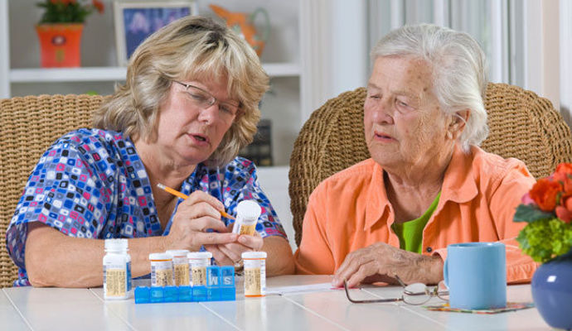

Making sure your loved one takes their medication is never easy. However, there are medication reminder services for seniors to simplify the process. Using the latest technology, hundreds of devices, mobile apps, and alarm clocks can provide caregivers with the assistance they need. We rounded up a few examples to ensure your loved one receives the proper dosages.

Keeping track of medication reminders for the elderly can be difficult on your own but luckily, there is IOT to make the process easier.

### **Theoretical Analysis**

1. Existing problem

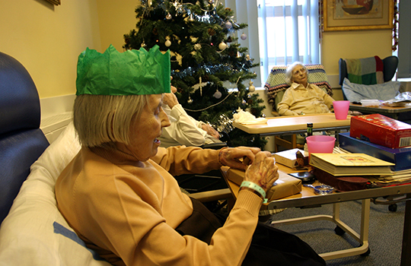

[This Photo](https://www.bmj.com/content/363/bmj.k4481) by Unknown Author is licensed under [CC BY-NC](https://creativecommons.org/licenses/by-nc/3.0/)

In modern society, busy life has made people forget many things in day to day life. The elderly people and the people victims of chronicle diseases who need to take the medicines timely without missing are suffering from dementia, which is forgetting things in their daily routine. Considering this situation study has been done in this.

1. Proposed solution

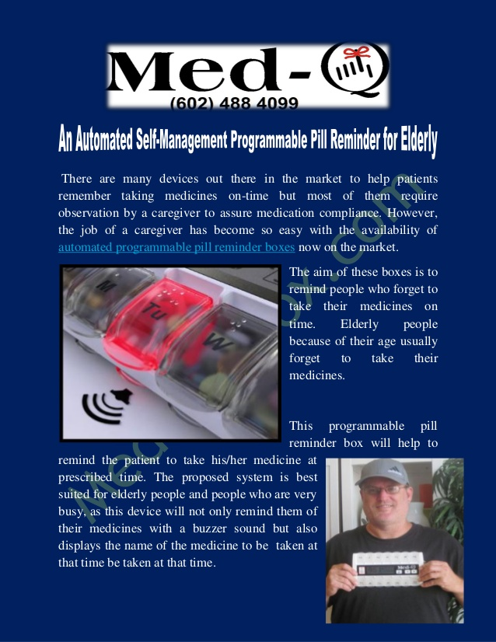

**To avoid this problem, this medicine reminder system is developed. An is built for the user (caretaker) which enables him to set the desired time and medicine. These details will be stored in the IBM Cloudant DB. if the medicine time arrives the web application will send the medicine name to the IoT Device through the IBM IoT platform. The device will receive the medicine name and notify the user with voice commands.**

**Experimental Investigation**

With the latest research in the fields of medicine and pharmaceutical sciences, an increasing number of drugs are being invented to cure many fatal diseases and this has enabled people to live healthier and longer. Consequently, the rate of medication usage is increasing, particularly among the elderly. It is important that the medication prescribed by doctors is taken at the correct times of the day and in the correct dosages. This seems to be a significant problem encountered by older people with disabilities. As a result of forgetfulness or other problems, many older patients either do not take the correct medicines or the correct dosage at the appropriate times and this reduces the benefits of treatments and increases both healthcare costs and the mortality rates. In order to find a solution to this problem, a IOT and Cloud-based smart application has been developed to improve patient adherence, particularly for older people with disabilities. The novelty of the developed application is the use of a Cloud service to provide two-way communication in the form of feedback between the older patients with disabilities and the doctors so that the medication adherence of the patients can be monitored.Developers should find the developed IOT mobile applicatio based medication reminder application for older people with disabilities a useful example application, and it should help them in developing other mobile applications for older people with disabilities.

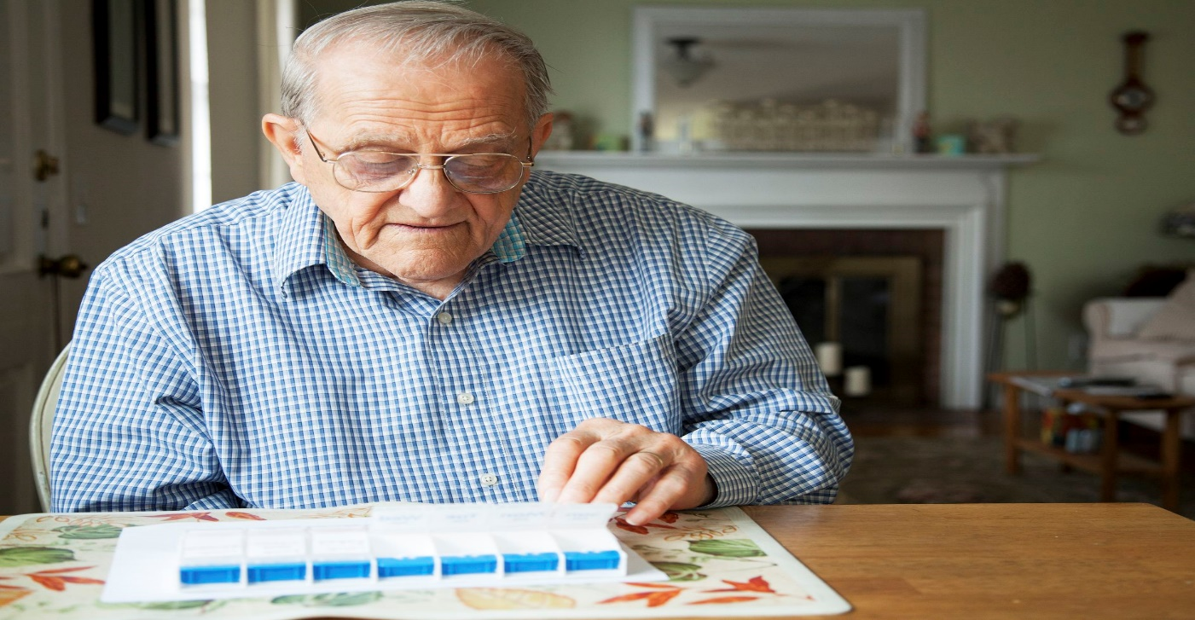

**Flowchart**

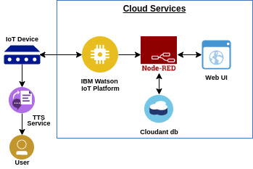

**Advantages & Disadvantages**

Advantages:

* For each medication you can include the prescribing doctor and food instructions.
* The app is easy to use for multiple patients, each with their own medications, reminders, reports, etc.
* There is a tool that allows you to check for potentially harmful drug interactions among the list of your medications, as well as warnings about things to avoid while on a particular medication (e.g. alcohol).
* The app can remind you when a prescription needs to be refilled.
* You can add reminders for doctor (and any other kind) appointments.

Disadvantages:

* The medication alert banner does not tell you which medicine you need to take. Unfortunately, you must go to the app to see which medication is due.
* Entering the information for each medication was a bit time consuming and cumbersome. There is a lot of scrolling required to get to the correct medication name and dosage.
* When I first started, I did not find this app easy to use. However, after using it for a while, it is easier to use.
* There is no way to use a distinct tone just for your medication alerts. This could be troublesome if you want to have a louder, longer tone for medications but don’t want to hear this for your other reminders.
* There is no way to set up customized “snooze” options. However, the app sends you 3 alerts (at your preset time, after 10 minutes and 20 minutes) if you haven’t marked the medication as “taken” on the app.

**Application**

More and more senior citizens in the world are facing the problem of living alone. People are social and need to communicate with other people. Loneliness is also damaging the health of senior citizens in some ways. Research shows that family companionship is very important for the elderly. It is worthy to notice that my product considers family companionship. I need to put this consideration to seniors’ daily life. So, how to alleviate loneliness for senior citizens in their daily life? As we all know, medication is a very important part for senior citizens. There are so many who need to notice when they should take their medicine. Then I came up with a solution: reminding seniors to take medicine seems a very emotional way to connect with their family members. Products on the market looks medical to seniors and they cannot have better relationship with their family members. My idea is to design a product that is easy for seniors to control and gives seniors more fun having a good and daily connection with their family members.

**Conclusion**

In modern society, busy life has made people forget many things in day to day life. The elderly people and the people victims of chronicle diseases who need to take the medicines timely without missing are suffering from dementia, which is forgetting things in their daily routine. Considering this situation study has been done in this. Paper reviewing the technologies of home health care which are currently used for improving this situation by reminding the scheduled of medicine, remote monitoring and update new medicine data of patients, which can be done by prescriber through web.

**Future Scope**

This project is about assisting seniors in their daily life. More and more senior citizens in the world are facing the problem of living alone. After research, I find that medication is a very important part of seniors’ life. My design is about medication reminder that can also connect the seniors with their family members. At first, I focused on the social relationship of senior citizens and started to research medication reminders in the market. I also read many books and magazines about the medication of senior citizens and try to figure out the size and volume of my design. Then I made mockups to try to test the best way for seniors to control a reminder such as the behavior of remembering medications to take. After that, I made my prototypes and brought them to the nursing home. More refinements were made after these discussion in the nursing home. The final version of my design uses an interesting and noticeable way to remind senior citizens to take their medicine. Besides that, my product can connect to phone or a device of seniors’ family members, which gives seniors better connection with their family members.

**Appendix**

Source code

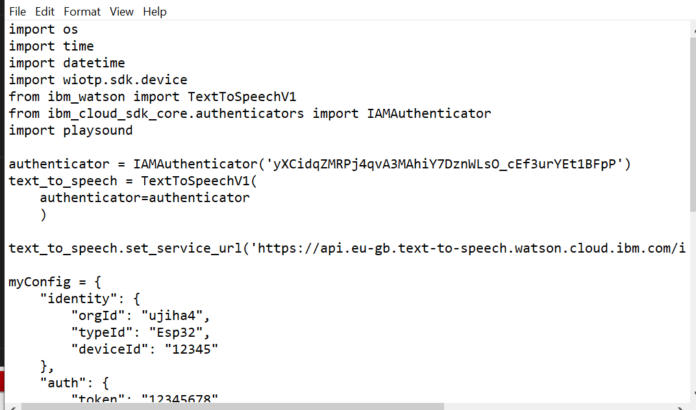

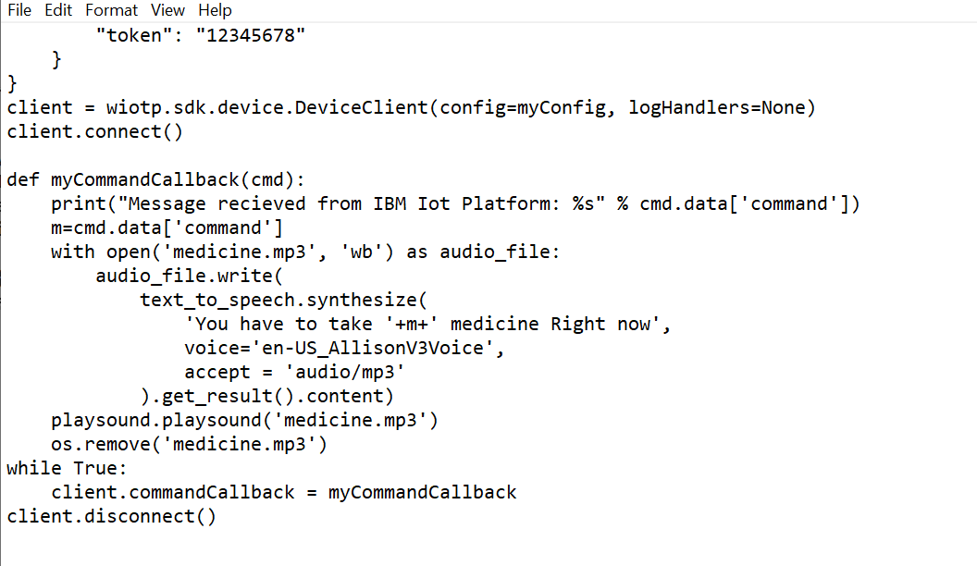

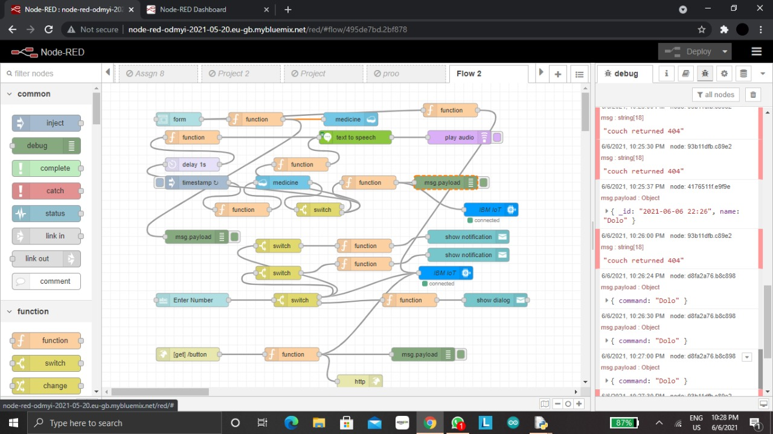

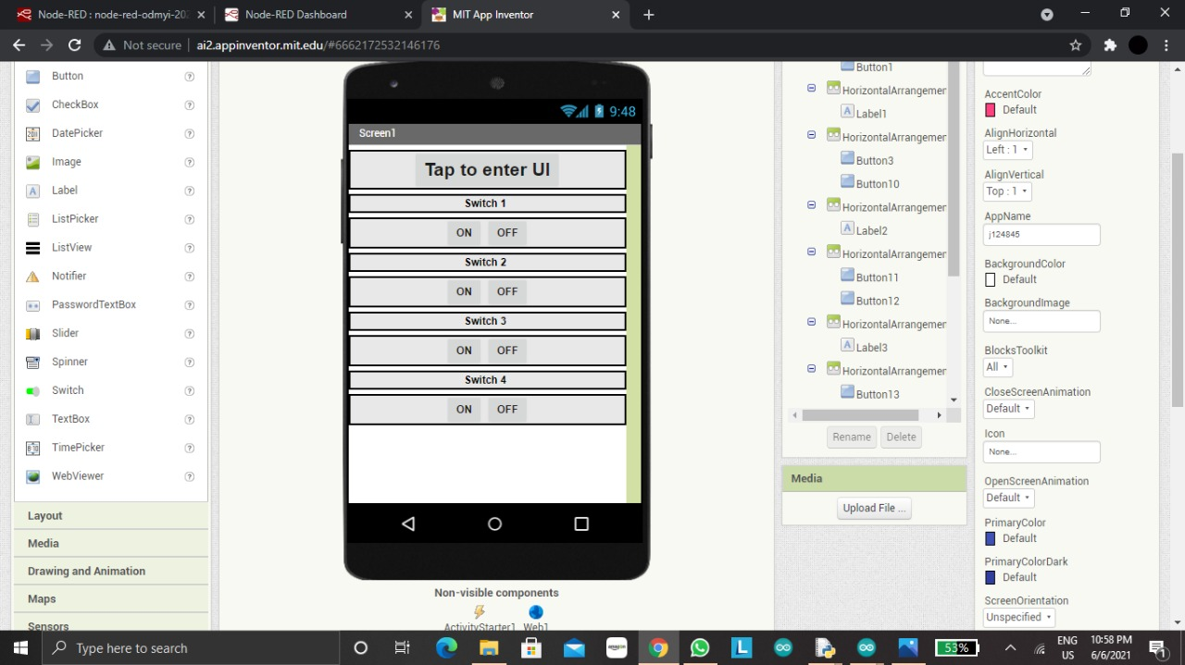

UI output Screenshot

